

SWG Dark Rebellion

Dungeon Master’s Handbook

Edition I

© 2022 Borrie BoBaka

Table of Contents

Welcome to Dungeon Mastering

Dungeon Mastering and Playing

Getting Started as a Dungeon Master

Inspecting PCs and NPCs

Messaging the Players as a DM

Speaking In-Character and Out-of-character Locally

Speaking through NPCs

Spawning in new NPCs

Spawning in Structures and Items

Controlling NPCs

Posture and Mood

Moving NPCs

Making NPCs Attack Targets

Orchestrating Combat

Death and Incapacitation

Non-Permadeath Party Wipes

Player vs. Player

Rewarding the Players

Things to Avoid

Joining as a DM & Qualifications

# 

# Welcome to Dungeon Mastering

From the very first roleplaying game to today, Dungeon Masters have been the pivotal point in orchestrating the story of a game, facilitating its rules, and making the game fun and interesting for everyone involved. Dungeon Masters have not been a very large part in Star Wars Galaxies roleplaying, but the role has existed in some form or capacity in every community. More often than not, this role has been delegated to the guild leader, or the mayor of a town that facilitates roleplay. Even by passively ensuring that everyone is following the rules of the community, they are performing basic tasks of the Dungeon Master.

Dark Rebellion has a more literal implementation of the Dungeon Master, inspired by the system integrated into BioWare’s *Neverwinter Nights*. The most common elements of a Dungeon Master’s tasks in game is to interact with the players and their ability to perform nearly any action thinkable within their own reason, and command non playable characters to ensure their world feels filled, and alive.

Dark Rebellion has three classes of Dungeon Master.

* **The Event Dungeon Master**

This type of Dungeon Master focuses primarily on events that will typically remain in one location, doing a certain activity for a period of time during the day or night. These Dungeon Masters most closely resemble Event Coordinators on an official SWGEmu server, or someone part of a roleplaying community who wishes to put on something special for said community. Event Dungeon Masters are responsible for coming up with interesting events that allow for passive roleplay that does not necessarily mean a combat encounter. These can range from casino nights, to racing competitions, to even arena battles. Event Dungeon Masters are the backbone to casual and continuous roleplay throughout the server.

* **The Mission Dungeon Master**

This type of Dungeon Master is the one who will design and/or execute missions and opportunities for other players to engage with, or facilitate requests by players to do a task that would require a Dungeon Master, like robbing a bank or spelunking a cave. This type of Dungeon Master is a bit more involved with activity, and will see the most combat action by players. Mission Dungeon Masters help characters perform tasks that allow them to grow and develop, and offer them the extra-curricular activities that enable Event Dungeon Masters to give the downtime for.

* **The Meta-Dungeon Master**

This type of Dungeon Master is the one who orchestrates larger events, galactic factional play, and large scale events that take a long period of time to complete. Meta-Dungeon Masters will often be assigned a large portion of the galaxy to oversee and handle, such as a major faction. Meta-Dungeon Masters are more commonly DMs who do not play player characters, or if they do, it is rarely or to participate in another DM’s events. It is up to the Meta-Dungeon Master to ensure that there is something interesting going on in the galaxy which can help propel the other DMs to do interesting events based on what is going on.

# Dungeon Mastering and Playing

Not everyone wants to just be a player. Not everyone wants to just be a Dungeon Master. While being just one or the other is a valuable thing, it is not an expected quality of Dungeon Masters within Dark Rebellion. Naturally of course, being both a player and a Dungeon Master could potentially give the player aspect unfair advantages over other players due to nepotistic behavior. Generally, any instance of a DM’s player character getting involved in one of their own events would need to be approved by the Head DM, submitting a brief report on how that character will be involved, and what they stand to potentially gain or lose from participating in an event. Generally it is frowned upon to run a Dungeon Master event purely for your own character, especially since that would be a relatively lonely mission, but it is typically considered useful to utilize your own character to help propel potential characters into the story that you have set up.

Regardless of this, Dungeon Mastering can take up valuable time from playing a character, and that can lead to potential issues with trying to catch up to other players while also giving them an interesting and fun experience. On a case to case basis, the Head DM will typically grant experience points to one of the DM’s player characters for a job well done in carrying out their duties, either by hosting an event or a mission. This also helps offer the DM a tangible reward for their hard work, beyond the happy faces of players and the satisfaction of being a DM.

# Getting Started as a Dungeon Master

Dungeon Masters will each have their own special account for DM activity, which is given an appropriate admin level to allow them access to basic SWG Admin commands like “teleport” and to become invisible. When you log in as a DM, you’ll want to be sure to remain invisible to ensure that you don’t disrupt the immersion of other players who may be roleplaying. You can do this by using the command **“/invul invis”** to switch on invisibility. Unlike standard SWGEmu servers, the character is not shrunk down to denote invisibility, as this often causes camera and annoyance issues for the DM. To check to see if you are invisible, you can do the command **“/invul check”** to see if players can see you or not.

Once you’ve settled in, you’ll be able to mark yourself as an active DM on the Discord and Server. Use the command **“/dm status”** to set your current status as a DM. Whatever message you place will be visible when players use the command **“/rp who”** on the server. When you’re done being active, and wish to return invisible to the player count, type **“/dm status clear”** to clear your status.

To keep tabs on players coming and going, you can use the command **“/dm togglenotify”** to get a friends-list-style update when a player logs in or logs off. This can be paired with the **“/dm who”** command which gives a much more in-depth look at who is online as opposed to the player’s **“/rp who.”**

## Inspecting PCs and NPCs

As a DM, it is a valuable asset to be able to see what kind of skills players and non-player characters have, in order to best get an idea on how to handle strategy in a mission. DMs can see the skills and weapon stats of an NPC simply by examining them in-game. These values will be applied when you target the NPC and use any dice bag command on them, such as “persuasion.”

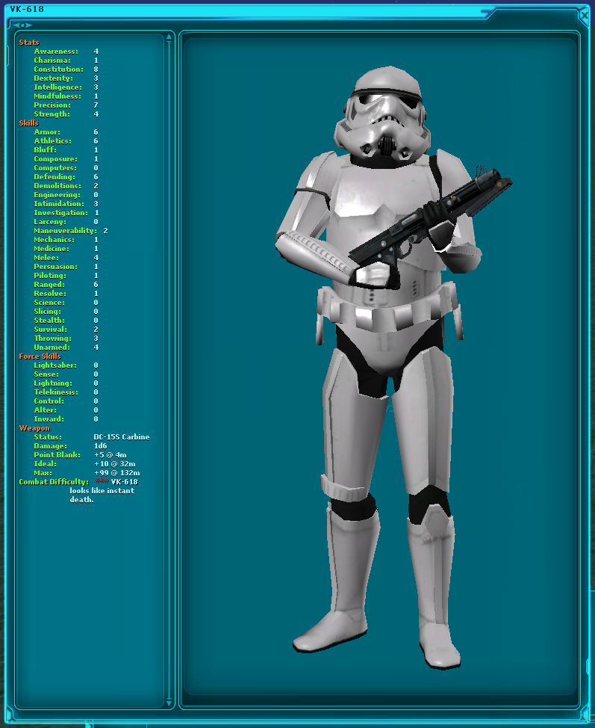

For players, this is slightly different. To inspect what stats a player has, you can target them and use the command **“/dm inspect”** This will give you a readout of their skills, money, free skill points, and Force Sensitivity data, among other things. This is the best way to get a read on a player’s standing in order to know how to handle them. Level is used to denote what kind of advancement the character has achieved, calculating their skills and equipment. This is used for automation of rewards.

# Messaging the Players as a DM

There’s a few commands that allow you to communicate with players both directly and indirectly, to give them a “voice of god” response to a question or action. You can also speak and emote through NPCs. A DM character cannot speak with other players with spatial chat, due to the fact that they are invisible. Instead, you’ll have to communicate through players using these commands, or through the OOC channel.

## Speaking In-Character and Out-of-character Locally

You can use the command **“/dm ic <message>”** to send a message to all nearby players, which will display both in the chat box and on-screen. In-character messages do not have a DM’s name attached to them for the sake of immersion, but they will display the name on the Discord Bot’s logging in a special format.

To speak to all characters locally out of character, you can use the command **“/dm ooc <message>”** to send a message through the chat-box only to all nearby players to communicate out-of-character messages.

Finally, in terms of direct DM communication, you can target a player and use the command **“/dm msg <message>”** to send a message to that individual character privately. This is valuable if you want to send players messages that only they receive, so they can use the information on their own with others. A good example of this would be to give the player a message only they can read on the screen of a computer. This way, they can communicate this new information on their own through roleplay.

If you ever felt so inclined, there is nothing wrong with sending private messages to a player, or sending them messages through the in-game Email system. However, these message systems can feel more cinematic and immersive to players, so it is recommended to use them when you can.

## Speaking through NPCs

A Dungeon Master wouldn’t have a good time if he or she wasn’t able to control and communicate as NPCs, as they are the very foundation of your ability to interact with the players. NPCs are capable of speaking the full range of possible emotes and message types that players can. Each spatial chat type has been programmed to be usable by the DM. Both DMs and players have the ability to speak through NPCs, but only DMs can speak through NPCs without a displayed nametag to show who is speaking through them. For Dungeon Masters, the most basic command to speak through an NPC is **“/dm say <message>”** and the player equivalent is **“/rp say <message>”** You can swap out “say” for any spatial chat type, like **“/dm yell <message>”** You can also use the custom emote shortcut **“:”** to make an NPC send emotes, for example **“/dm : waves hello”**

One restriction of this method is that you cannot use a stock emote such as /wave or /bow on an NPC. This is due to a restriction of how the game handles emotes itself in chat. You can, however, animate an NPC by using the **“/anim <animName>”** command, such as **“/anim wave2”**

# Spawning in new NPCs

While you could just use NPCs as they are spawned around the world for your event, you’ll likely want to have your own custom NPCs to play with. Dark Rebellion features a more comprehensive NPC spawning system to allow for easy creation of new custom NPCs.

In its most basic form, you can spawn in a creature using the command: **“/dm createcreature <template>”** The template is represented by an entry in the “object/mobile” directory in the files. There are over 2,653 different kinds of mobiles you can spawn from this list, however, Dark Rebellion has a few custom templates for easy creation. For example, every playable species has a template that follows this formula: “rp_<species>_<male/female>” This will spawn in a blank, naked variant of that species.

Example: /dm createcreature rp_human_male

This NPC has no skills, equipment, or even customization. This might be fine if you want to create a filler NPC that is a creature or a droid, but you’ll likely want to go further than that. If you utilize the createcreature command with no arguments, you’ll be able to quickly see all potential arguments of the command, as follows:

/dm createcreature [<template>] <skill> <equipment> <customization>

You can select a skill template, an equipment template, and a customization template from a selected list of possible prefab files to create the NPC you want to make. For details on creating these files, please speak with the developer of the server to coordinate creating these files. These templates can be created without the need to restart the server, so you’ll be able to create new templates on the fly if need be.

For the sake of convenience, there are a number of NPCs that have fully randomized stats, equipment and customization based on a template, like a Stormtrooper. These NPC templates are typically used for world spawns, but can be spawned in for a quick NPC that doesn’t need to be completely unique. In that case, you can simply use the other command **“/dm createnpc <template>”** to immediately spawn in that NPC. Creating templates does require coordinating with a developer, but again does not require a server restart to be implemented.

Finally, you can drag and drop items, such as clothing and weapons from your inventory onto an NPC. The NPC will immediately equip that item and be capable of using it in combat if need be. You can do this to quickly dress a naked NPC if you do not wish to create a template just for this one NPC. Once you’re set, you can always give your NPC a custom random name by targeting him or her, and using the command **“/dm randomname <type>”** where type might be “human,” or “bothan” to give that NPC a random name of that type.

Whenever you’re done with an NPC, you can simply type **“/dm delete”** to despawn that NPC.

# Spawning in Structures and Items

So now you have your cast, but what about your set? You may not always need to create a new interior or building to begin your roleplay event, but you may feel the desire to, or need to do some modifying quickly to an interior. Note that any custom server-side decoration of a building spawned in by the snapshot may be subject to being wiped when the snapshot is updated on the server. Player structures spawned in by the DM however, will not be. You can spawn in just about any structure by using the command **“/tool createstructure <template>”** which will spawn the structure at your location, facing your direction.

Item spawning is the same as a standard SWGEmu server, with the /object command. You can however copy objects by simply targeting them and typing the command **“/dm copy”** or using the DM Options radial menu while it is in your inventory.

The DM Options Radial Menu will also allow you to do things like set a custom description for the item, to be read when examined. You can also conveniently rename the object here, or give it to a target player without needing to trade it.

There are more commands that are dedicated to making decoration easier, including placing objects outside and moving them around. However, this is more of the domain of the decorator, and will be covered in a Decorator’s handbook for the server.

All Items in player houses will always persist, however items dropped outside, and NPCs spawned will be lost when the server restarts. Decoration formats and layouts can be saved however to be re-used later in different interiors.

# Controlling NPCs

Now that you know how to create an NPC and talk through them, let’s discuss the further details of controlling an NPC. Controlling NPCs is one of the biggest aspects of being a Dungeon Master that players cannot do themselves, for the sake of keeping integrity in the server and preventing abuse. While Players can speak through NPCs, control of them is limited to Dungeon Masters to ensure that the server remains immersive and organized.

Due to limitations with SWG that have not been broken at this time, there is no way to completely control and possess an NPC like is possible in *Neverwinter Nights.* Instead, we are able to move NPCs through a modification of the patrol point and follow system integrated in the AI.

## Posture and Mood

You can control the posture and mood of NPCs to give them a bit more life, and to indicate their status to other players. Moods can be assigned by string to any NPC by using the **“/dm mood <mood name>”** command. Any valid mood string will do, even ones that are not available to players normally.

Additionally, you can set the posture of an NPC using **“/dm setposture <posture>”** to have the NPCs kneel, sit, stand, and even appear as a corpse if they have been defeated. This command can also be applied to players if need be.

You can make an NPC toggle into combat mode just as you can as a player, by targeting an NPC and typing the command **“/setcombat”** This will put the target into a combat stance, aiming their weapon or holding it at the ready. As of writing this, however, this feature has unreliable effects while an NPC is in an interior structure. An NPC does not need to be in combat in order to attack, however.

## Moving NPCs

Moving NPCs is typically done through the use of three key commands, each of which have an icon in the Command Browser (CTRL + A).

**/nface:** This command will make the NPC face you wherever you are. This is an easy way of making an NPC face a certain direction, or look at others.

**/nfollow:** This command makes the NPC follow you. Even if you’re invisible, the NPC will follow you and appear to be moving on its own to a location to players. You can utilize the command **“/nfollow walk”** to force an NPC to walk instead of run to their destination. You can also use **“/nfollow direct”** to have the NPC follow you and stand ontop of you directly instead of behind you for more precise movement. You can have as many NPCs following you at once, though they may gather together into one spot.

**/nstay:** This command makes the NPC stay put where you’re standing. They will cease to follow you. If the command is used while the target is not following you, they will simply walk to that location and stay there permanently.

## Making NPCs Attack Targets

Dungeon Masters can orchestrate combat by having an NPC attack another target, be it a player or another NPC. Because we can’t target two things at once with the game’s mechanics, we have to designate an NPC we wish to be the attacker, and represent our next move.

To target an NPC as our attacker, target the NPC normally and use the command **“/ntarget”** and this will store that NPC as the NPC to attack.

Once you have your NPC stored, target the NPC or player you wish for that NPC to attack. Use the command **“/attacknpc”** to have that NPC then perform a combat action on that target. You can use the argument “faux” such as **“/attacknpc faux”** to have the NPC animate and display an attack on a target without actually attacking them. This is a neat effect that allows you to create the feeling of an intense battle even between turns.

To adjust hitpoints and other elements of a character, you can utilize the Dicebag and Adjust Health commands to alter their hitpoints as long as you have that NPC targeted.

# Orchestrating Combat

When a Dungeon Master is involved, it is typically up to them to meditate and manage combat, especially when the combat involves NPCs that they control. Players are typically left to freely roam, explore, emote and interact with the world until one of them gets involved in combat, similar to how combat is handled in something like Larian Studios’ *Divinity: Original Sin 2.* When combat begins, it is up to the DM to decide what the turn order should be. Typically, the first turn is granted to the first person to attack, followed by the NPCs that you control, but this is not a rule, just a suggestion.

You can broadcast to all the participating members the decided turn order by using the **“/dm ooc <message>”** command, typically with arrows pointing in the order from left to right. Each player gets their own turn, and then every NPC controlled by you takes their turn at once. It is not required to emote every attack, but if you’d like to add extra flavor to your roleplay, you are always welcome to. An example turn order is something like this:

Ihe > Ashlynne > Borrie > DM

When you’re done taking your turn, it is imperative to inform the others of who is next in line to act. They will signal the end of their turn with the **“/endturn”** command. It is up to you to moderate that turn order is respected, and that mistakes are erased if someone attacks in error. If someone causes problems or interrupts this often, you should politely escort them out of the RP.

## Death and Incapacitation

Running out of health does not cause a player or NPC to go into a death state, in order to allow greater freedom of what happens when one runs out of health. If an NPC or player runs out of health, the general area will be alerted to this fact. The DM may rule if whether or not a target has been incapacitated (and unable to resume battle until healed) or killed.

Permadeath is a possibility in Dark Rebellion, but it needs to be labeled as a clear possibility to the players prior to beginning a mission. More dangerous and riskier missions can be more rewarding, but also be a potential cause of death. Before a player enters a mission, they should be firmly informed out of character whether or not that the mission could lead to their demise. Otherwise, defeat will lead to capture, or a “white out” in the style of the *Pokemon* games.

## Non-Permadeath Party Wipes

It’s easy to dust off your hands and call it a day if a party is wiped and permanently killed, but more often than not you will encounter non-permadeath party wipes. On the occasion that this happens, you will be up to decide what fate is to be made for our party. More often than not, you will want to teleport the party to the nearest medical center or camp, and inform them that they’ve come to, either rescued by an unknown force, or managed to this location before collapsing and being healed. There is no penalty for this sort of defeat other than a bruised ego and a missed opportunity.

## Player vs. Player

It’s not impossible for PvP to occur in Dark Rebellion. The game systems are designed to allow players to fight each other without the need for a DM to be involved, as they can monitor each other's moves and prevent cheating. However, in some heated battles, especially ones that might lead to permadeath, they may wish to involve a DM to mediate the battle. In this case, you will monitor the battle and ensure that everything goes smoothly, and accommodate special requests (like non-explicit actions that don’t have rules attached precisely, like throwing a chair at their head.)

# Rewarding the Players

After a job well done, there’s a few things to consider when it comes to rewarding the players for their efforts. There is the matter of experience, money, and items.

You can reward experience and credits to a player by using the **“/dm reward credits”** and **“/dm reward exp”** commands to reward the players based on a sliding scale that is dependent upon their internal level, which is calculated using their skills and stats. This helps take the guesswork out of rewarding players. However, this system is mostly reserved for smaller missions. Some missions may have explicit rewards stated prior to the mission, like a credit value. Or you might have the players stumble upon something interesting they can take home. You may also wish to reward more experience for players who went above and beyond to roleplay. This is at your discretion, but caution is advised not to overflow their pockets with goodies to help keep things fair.

As for items, many players will often want to loot the surrounding environment of items, or loot enemies for their weapons or armor. Generally, this is acceptable, though you may wish to limit how much they can take home to again keep things fair. You cannot give the player the exact weapon an NPC used in battle, but you can freely give them a copy of that weapon as though it were the one lifted from the corpse. It is always alright to simply state that the weapon is damaged beyond repair, or tell them what kinds of junk loot they’ve acquired, and reward them credits based on their combined value.

# Things to Avoid

Being a Dungeon Master is one thing, but being a good Dungeon Master takes practice, skill, and experience. There are a few things you might wish to avoid while being a Dungeon Master, in order to keep players happy and the quality of your work high.

**Retcons / Reversals**

Sometimes a player might do something they regret, or you might accidentally do something that may be a little too much or too little for the party involved. The worst thing you can do is allow this to be reversed or “retconned” to delete that element from the story. This can feel extremely cheap to players, and make them unable to rely on the world remaining consistent with their actions. Consider every action like you’re playing on Iron Man mode, where you can’t reload a save to try something else. Remember that losing can be fun, and mistakes can lead to interesting and wild possibilities.

**Protagonist Syndrome**

Try to avoid focusing too much on a single player character in a roleplay, even if they might be putting in the most effort of a party. Some players might simply be too timid or don’t know what to do, so they follow someone in hopes to learn and understand the game better. Try to make NPCs approach them, talk to them, or even attack them to help give variety and not focus on a single character too often, or it can feel more like the story is about that character, when a DM’s purpose is to bring RP to many.

**Excessive Time Jumps**

There is no unified clock for all the roleplay in Dark Rebellion, with RP generally being around the same time as a Meta-DM determines how much time has ultimately passed in the galactic sense. Try to avoid jumping days, weeks or months into the future as best as you can, and try to allow players the chance to live in the moment when you can. Unless you can help it, also try to avoid teleporting players unless actual time for participation is limited, and the destination is far. Try to encourage communication while on speeders when you can!

# Joining as a DM & Qualifications

Dungeon Masters are as important to the smooth and successful operation of Dark Rebellion as are the players. If you have the desire or the interest to become a Dungeon Master, then that can be all that it takes. The qualities that are most sought after for DMs in Dark Rebellion are those who can come up with interesting ideas, and roleplay them out. People who can multitask as you deal with multiple players roleplaying. People who are interested in telling stories that are beyond just a single character.

While experience as a Dungeon Master is always preferred, we’re happy to seek out new Dungeon Masters who might be interested in the craft. We have multiple levels of DM involvement, and assistant DMs may be valuable to extend the capability of a single DM while training new Dungeon Masters.

If you have interest in being a Dungeon Master, please contact a Dungeon Master or the Head DM for more information.